**Project Proposal**

**Title: Market Management Application**

**Definition:** Market management system is the system where all the aspects related to the proper management of market is done. These aspects involve managing information about the various products, staff, managers, customers, billing etc. Also allows the customer to purchase and pay for the items purchased.

**Goals:**

i) Increase sales

ii) Generate leads

iii) Acquire new customers

iv) Increase customer satisfaction

v) Up-sell and cross-sell

**View of our project:**

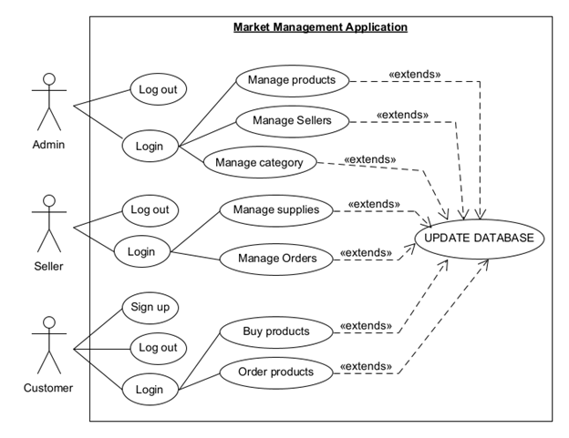

**User:**

* Admin
* Seller
* Customer

**Targeted and Features:**

* Manage products:-

i) Id

ii) Name

iii) Quantity

iv) Price

* Products category

i) Beverage

ii) Meat

iii) Grocery

* Manage sellers:-

i) Name

ii) Phone

iii) Password

* Manage orders:-

i) Bill No

ii) Sell Quantity

iii) Sell Date

iv) Product Name

v) Product Price

vi) Total Amount

* Order Form:-

i) Product Name

ii) Product Id

iii) Product Quantity

iv) Product Price

v) Product Category

vi) Show Total Amount

**Benefits:** Admin can easily access product and seller details. He can add or remove seller and also can add product by using this application. He can easily see the list of product. Seller can easily sell products to the customer. He can generate bill id in a short time and also can print out the bill.

* Saving in labour cost due to self-service system.
* Reasonable or low prices of goods.
* Low cost of operation.
* Freedom of selection.
* Shopping is very easy and quick.
* Due to adequate parking space, shopping becomes easy and pleasing activity rather than boredom.